Dear Friends,

As I write this article, we’re expecting our fourth straight day in the upper 90s, with heat indices above 105°, and next week looks even worse. It’s safe to say, it’s just been HOT. Really, really hot. Spending ten years on the Alabama Gulf Coast, I’m pretty used to hot weather and high humidity, but the Gulf of Mexico kept us from getting too much above 90° most of the time. The weather this week has had me thinking about the last time I felt this hot for this long, which led me all the way back to July of 2009.

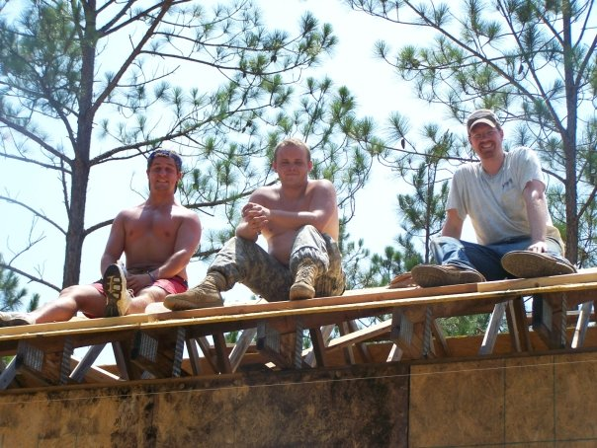
Nearly four years after Hurricane Katrina had ravage the Louisiana and Mississippi coastlines, a group of youth and some adult chaperones from Saint Paul’s made our way two hours west from Foley to help demolish and rebuild homes in and around Bay St. Louis, MS. We did all kinds of work that hot, humid week, but the most intense was the afternoon they put Ian, Michael, and me up on a roof, some 30 feet in the air to sheath a house whose progress had been stalled by illness and lack of funding. As you can tell by the photo, it was a nice, sunny day, the air thick with mold and humidity, and no relief from the scraggly pine trees high above. It was a really challenging day, but the reward of knowing that a family that had been displaced for four years was going to one day get a roof of their own over their head made it all worth it.

As we look ahead to July, Christ Church has a similar opportunity on the horizon. Alongside our siblings in Christ at First Christian Church and The Presbyterian Church, we’ve committed to help Habitat for Humanity build the walls for six of the ten homes they plan to build this summer. Given what we are already experiencing, the hope of a random, cool weekend doesn’t seem likely, but that only means that teamwork will be all the more important. Maybe you can’t swing a hammer a couple thousand times in the summer heat, but if you can roll a cooler around to provide the relief of cool water, we need your help. If you can team up to carry lumber, help make breakfast, or work the registration table, we need your help. If all you can do is donate money, that’ll help too, as we try to raise $12,000 to match the contribution of our Tornado Relief Fund.

I hope you’ll find a way to support this important project as our community teams up to help displaced families get a roof of their own over their head. If you have questions, don’t hesistate to reach out. If you want to sign up, you can do so at http://www.helpbuildhope.com/bowlgreen22 or by pointing your cell phone camera at the QR Code.

