Learning to Walk in the Dark
The Reverend Barbara Brown Taylor
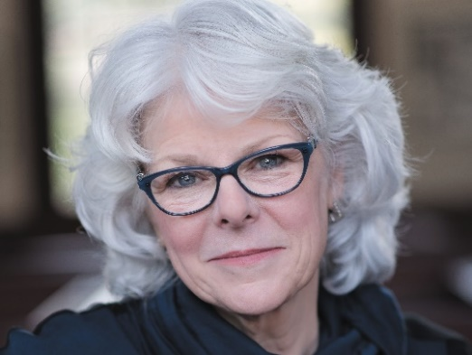
Barbara Brown Taylor is an accomplished writer and speaker, writing eighteen books and contributing to many others. She is by any measure a very influential theologian. You will find her to fall somewhat to the left of center, not because of what she believes but rather how she focuses on understanding God and our relationship with God based on what she observes and discerns.
Taylor was born on September 21, 1951, in Lafayette, Indiana – Emory University, 1973 – Yale Divinity School, 1976 MDiv – Ordained an Episcopal Priest 1984 – rector of Grace-Calvary Episcopal Church, Clarksville Georgia, 1992. In the early 2000s, she left parish ministry and became a professor at Piedmont College in Demorest, Georgia, and an adjunct professor of Christian spirituality at Columbia Theological Seminary in Decatur, Georgia. She has retired from both positions and lives with her husband on a farm in rural Georgia.
Her recognitions are many, including being in Time Magazine’s 2014 listing of the 100 most influential people in the world. She has been called a “spiritual contrarian,” she has been recognized for her preaching by many denominations, and, as an influencer of modern Christianity, she has been compared to C. S. Lewis.
Her 1997 book Bread of Angels inspired the name for our group eighteen years ago.
We picked Learning to Walk in the Dark as our first book for Bread of Angeles: Resurrection for three reasons.
- We picked it as a way to go back to our beginning and connect us directly to 18 years of conversation by some amazing people.
- Learning to Walk in the Dark is one of her most recent books and has drawn enormous attention and praise. We picked it on its merits.
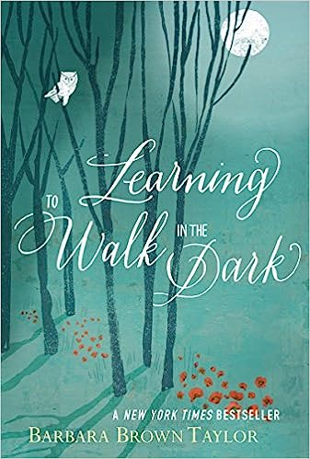
- And it seems especially timely as we have truly been walking in the dark for the last 30 months – still are in some ways. We picked it to help us learn from our experiences during that dark time in our lives.
What others are saying:
- “Few souls are as synched to the world’s mysteries as Barbara Brown Taylor’s … Taylor writes spiritual nonfiction that rivals the poetic power of C.S. Lewis and Frederick Buechner.” Time Magazine
- “… offers a different way of looking at darkness, not as something to be feared, but as something to be embraced.” NPR

