Being Disciples, Essentials of the Christian Life
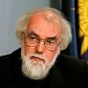
Meet Rowan Williams
Discipleship is a state of being…. Discipleship is about how we live; not just the decisions we make, not just the things we believe, but a state of being.” (pg. 1)
Rowan Williams, the 142d Archbishop of Canterbury, truly is larger than life in many ways. Being primarily an academic, he was the first Archbishop of Canterbury in modern times not to be appointed from within the Church of England, holding the post from 2002 to 2012, a difficult time when the Anglican Church writ large was on the verge of fragmentation over disagreements on contemporary issues including the ordination of woman and homosexuality. He resigned after unsuccessfully securing a sufficient majority for a measure to allow the appointment of women as bishops in the Church of England. In what was a distinct echo of his influence, women in the Church of England were first appointed bishops in 2015, including one who was appointed a Lord Spiritual (Bishops who are members of the House of Lords).
Williams has been a prolific writer and speaker, both in the academic press and popular press. Being Disciples is one of three related collections published after his tenure as Archbishop: Being Christian (2014), Being Disciples (20160, and Being Human (2018).
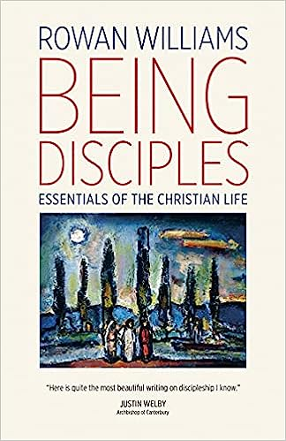
His book, Being Disciples, Essentials of the Christian Life, is a collection of essays about discipleship. In today’s diverse Christian community, old words sometimes take on strange new meanings, making it useful to go back to roots. The word disciple comes from the ancient Greek and was meant to describe the students who associated themselves with more mature scholars and followed in their path. In a Christian context, which is its most common usage, it can be best understood simply as one who aspires to follow the path described by Jesus.
What others are saying:
- “Here is quite the most beautiful writing on discipleship I know.” Justin Welby, [143d] Archbishop of Canterbury.

